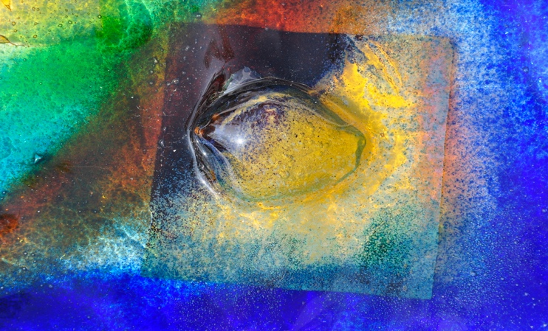

Kiln formed glass workshop

All courses are suitable for beginners; no previous experience of glass fusing is required and all materials/tools are supplied. Refreshments are provided on the day.
You will have the freedom to work on a design of your choice regardless of what workshop you choose.
Full support & guidance will be given on how to handle and cut glass safely.

Full day workshop 10-4pm includes veggie lunch £100

Demonstration on powders, confetti, stringers and coloured glass. Handouts will be given to support your activity. You can work on your own designs to produce 4 glass coasters and a glass hanging (24cm x19cm).

Taster day workshop 1-3.30pm £50

Produce your very own hand made light catcher to hang in your window! Using either a stencil or free hand with coloured powders you can create your own design as a present for someone or just to keep for yourself.

Jewelry workshop 10-12-30 £35

Produce a unique glass pendant using sparkly dichroic glass (size and design of your choice).

Please bring a sketch book, wear trousers/appropriate clothes and cover your feet

Fusing will take place after the workshop and will be ready within 1-2 weeks

Contact Elaine Kelly 07507152379
Held at my studio
40 Church Rd, Willington, Bedford Beds MK44 3PU

